**Project 5**

**Project Name: Scheduling a basic job in Jenkins**

Task1: Create a free style project

ss: Jenkins home page with job list

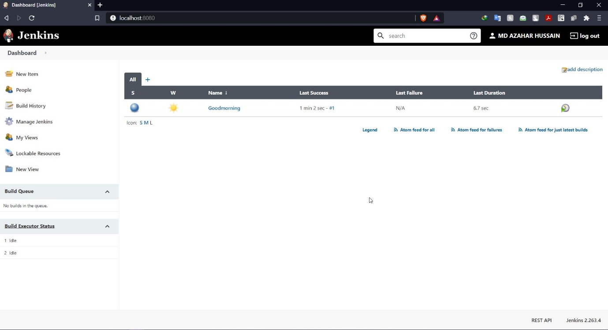

Task2: Configure git SCM

ss: git scm config tab with the commands

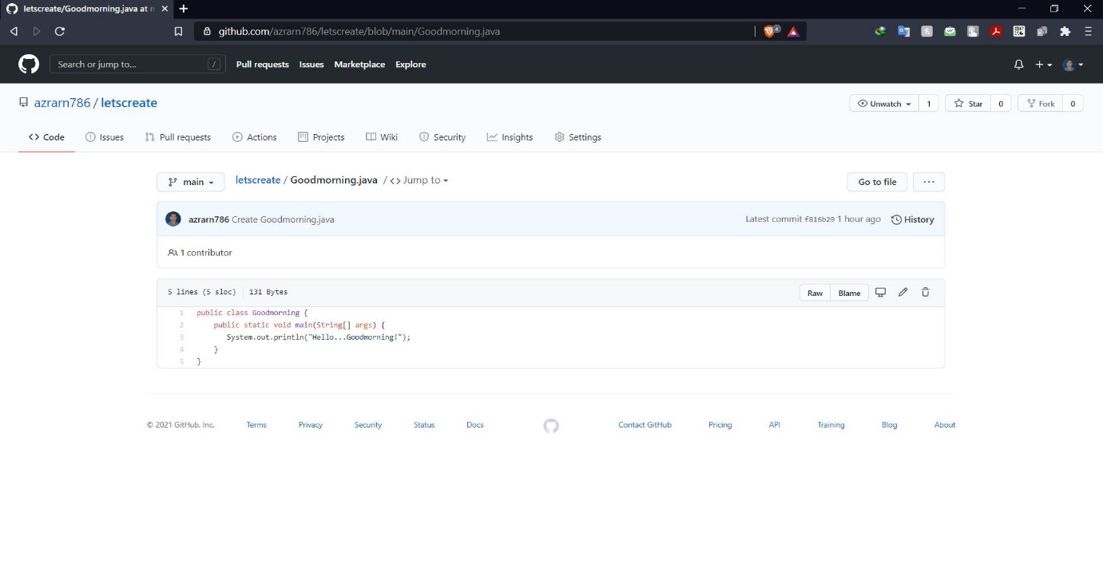

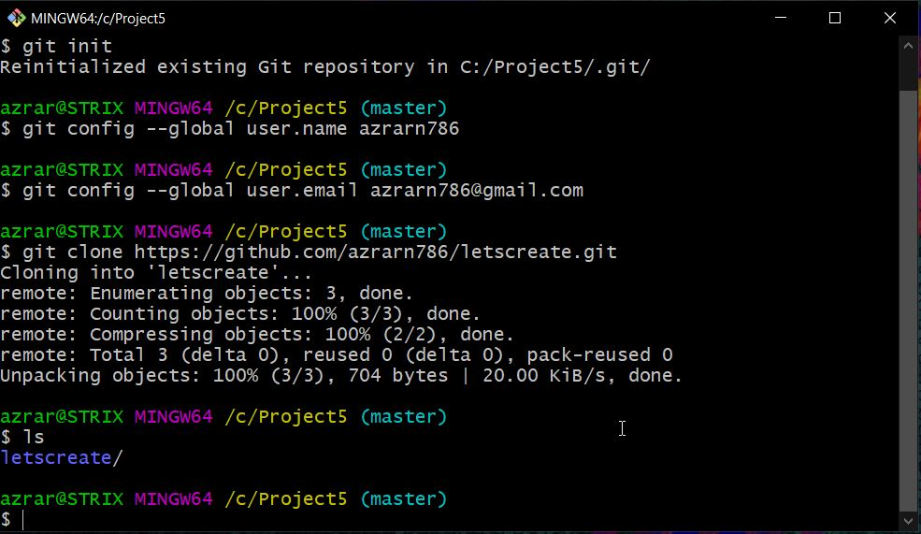

Task3: Add build step-java commands in execute windows batch commands

ss: commands to compile and run java program

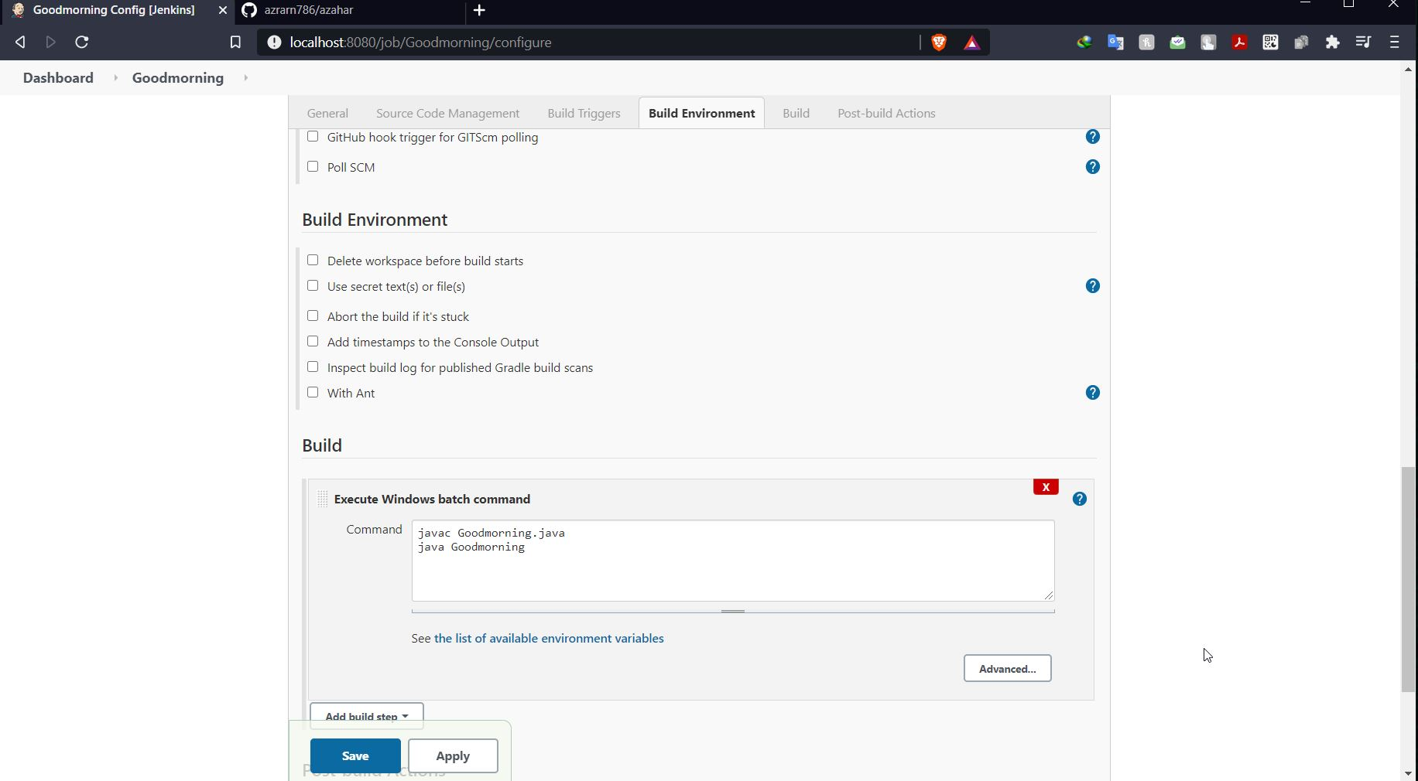

Task4: Run a build and show console output

ss: console output-build successfully

